irThis is our first testing of the gotify testing between the pi and the mobile app:

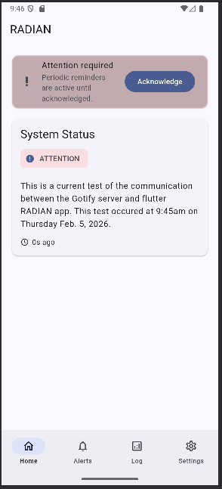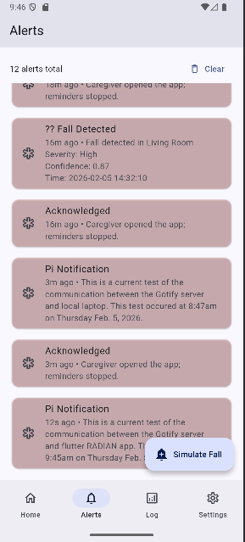

What needs to be debugged on the app:
- Alerts are coming through the alert tab bottom to top, needs to be top to bottom
- Need to get rid of the internal simulate fall alerts now that we have connected the gotify server
- The alerts coming from the gotify server are not being uploaded into the fall log
- In the settings change “app token” to “client token”
- Change the “Gotify Connection” box in the settings tab to collapse when the emulator has connected to the server, as a sign of connection
- Any place where there is a “____ ago”, change it so that it updates with the time instead of updating the time that has past when you leave the tab and go back to that tab
- If it already isnt in the code, add code so that when there is a fall alert, have the alert make note of what kind of fall it was and where, because the data will already be classified this way

